CSS321 Software Assurance
Software Assurance Guidelines
Paul Terrell
08 November 2017
Phase 5 Individual Project

Contents

Project Outline 3
Security in the Development Life Cycle 3
Software Assurance Techniques 4
Security in Nontraditional Development Models 7
Security Static Analysis 10
Software Assurance Policies and Processes 14
References 19

Project Outline.

Company Overview

AtHoc is a company based out of San Mateo California and was established in 1999. The company specializes in software for mass notifications to include natural disasters, force protection, and general emergency situations. AtHoc currently employs over 10,000 people across offices in California, Colorado and Massachusetts. The Company sells software for emergency notifications to DOD, DHS, American red Cross, Microsoft, and other government agencies. The software is installed on each client within the organization and notifications are managed and send out by an office such as an operation center, fire department, police department, etc. The managing agency can also use a web client to send out notifications and the database is managed by AtHoc.

Security in the Development Life Cycle.

Securely handling product and customer information is crucial. Privacy is paramount for both the Company and the individual. Listed is the SDLC order in which the company follows.

Stage 1- Planning and Requirement Analysis – The senior members of the team perform. This stage with inputs from the customer. The input is used to draft a plan in order to create a basic project guideline while conducting product feasibility study in the economical, technical, and operational areas.

Stage 2- Defining Requirements – This stage will define the proper requirements used for software specifications, security, and longevity.

Stage 3- designing the product architecture – This Company will use SRS for a reference for product architects to ensure the best product is developed. More than one design approach can be made to ensure efficient development.

Stage 4- Building and developing the product – The code is generated as per DDS during this stage. This is where critical security measures need to be adding into the program code to ensure strong coding.

Software Assurance Techniques

Analysis
AtHoc provides large companies and US Government agencies with a suite of software to notify individuals of an emergency. Each piece of software offered uses a database of company users which holds vital information like PC IP address, cell number, Twitter handle, etc.
The first piece of software is their Emergency Mass Notification program. This software is installed on every client PC within the organization. The software provides the following:
Communicate with personnel across all channels – networked computers, mobile devices, sirens, radios, fire panels and digital displays – with predefined procedures and two-way communication. Enable every individual to communicate and interact from a mobile phone, tablet, laptop, desktop computer, IP phone, email, text, interface or pager.Share map-based situational awareness, e.g., incident location and evacuation route, based on role and permissions. (AtHoc, 2017).
The second piece of software is used for accountability during an emergency to ensure each individual is accounted for. The software provides the following:
AtHoc Account enables real time visibility into personnel location and status for effective crisis management. AtHoc empowers commanders to determine which personnel are safe and which need immediate response. (AtHoc, 2017).
The third piece of software is baked into each application and is a database of every individual that belongs to the organization. One office, with a designated back up, is responsible for sending out emergency notifications. This agency ensures the database is up to date, but the database resides on the companys server and the softweare directly communicates with the database. Both applications have a web app in case systems are down.

Guidelines
SA in Acquisition and Outsourcing
- Software assurance in acquisition and contact language
- Software supply chain risk management and due-diligence
SA in Development
- Integrate security into the SDLC
- Practices for mitigating weaknesses
- Software security training (Risk Based)
- Analysis and requirements for secure software
- Architecture and design for secure software
- Secure coding and software construction
SA life cycle support
- Training, education, and certification
- Secure software distribution, deployment, and operations
- Code transparency
- Assurance case management (Jarzombek, 2012).

Security in Nontraditional Development Models
Some organizations today have their own customized methodology for developing their own software but the majority uses one of two methodologies: Traditional and Non-traditional. Traditional models base their approach on comprehensive planning, detailed documentation, and expansive design. Non-traditional models base their approach on employing short iterative cycles, and rely on tactic knowledge using a team of programmers instead of documentation (Awad, 2005).
AtHoc would benefit from XP (Extreme Programming). When you develop using the XP process, you develop in short cycles, incremental planning, continuous feedback, reliance on communication, and evolutionary design (Awad, 2005). XP development uses a two programmers concpt. One programmer will write the code, while the other will sit back and watch, giving feedback, helpful tips, and code checking.
XP has a six-step phase:
- Exploration Phase – The customer will write out story cards on what needs to be implemented into their program.
- Planning Phase – This is where the programmers will set priorities for each story, and then create a schedule for the first program release.
- Iterations to Release Phase – The programmer’s very first iteration is to design a system with the architecture of the whole system, while continuously integrating and testing the code language.
- Production Phase – During this phase, extra testing and performance checking of the system is done prior to release. Any postponed ideas and suggestions that were found during this phase will be documented for a later release in updates.
- Maintenance Phase – This is where the updates will occur to implement previous ideas, new technology, and fix bugs.
- Death Phase – This is the final phase that occurs when the customer has nothing left to be implemented and there is no more changes needed to the architecture, design, or code (Awad, 2005).
Listed below is what is implemented into each phase:
- Exploration – Regular updates, stories
- Planning – Stories for the next iteration, priorities, effort estimates
- Iterations to release – Continuous review, pair programming, analysis, design, planning for testing, testing, feedback, collective codebase.
- Production – Small release
- Maintenance – Updated release
- Death – Final release
During the first three phases of XP are the design, plan, and schedule phases. The security risks come into play during phases four through six. During these three phases, XSS and SQL injection attacks can take place. Two other popular attacks that can happen are authorized and unauthorized attacks, where a hacker can obtain username and passwords, eavesdrop on scripts to gain credentials and port sniff.
During the XP process, iterations are done quickly, which makes for short timeframes, in turn increasing risk. Implementing a security master would mitigate most risk. The security master is involved in ten XP practices:
- Planning game
- Coding standard
- Simple design
- Metaphor
- Small design
- Pair programming
- Continuous iteration
- 40-hour per week
- Collective code ownership
- Refactoring (Nguyen, 2015).
Adding Security and privacy requirements during the design phase can mitigate most threats during the XP process. Implementing a risk assessment guideline into the design and planning phase would be preferred. XP developers should utilize every SDL practice to ensure proper security measures.

Security Static Analysis
AtHoc continues to be the leader in automated notification systems. Increased sales, employee, and product growth, creates a large database. New applications will ensure customer information security, as well as better product design specification security.
Oracle ATG database with API:
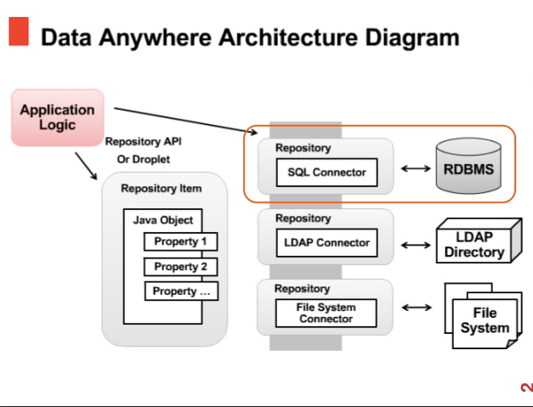
This diagram shows the key components for this database architecture. The repository API (atg.repository.*), is oracles foundation of object storage, user profiling, and content targeting. The SQL connector in the repository will enable an Oracle external table to access data store in RDMBS. The data can remain in RDMBS, or it can be located in an ATG database (Oracle, 2012).
The LDAP connector allows an organization to easily develop and deploy directory-enabled applications. It is a protocol that is more practical to deploy internet-ready applications, and it reduces the need to enter and coordinate redundant information in multiple services throughout an organization (Oracle, 2005).
The file system connector will expose an area of the local file system as a graph of nt.file and nt.folder nodes. This connector can be configured so that the workspace name is either a path to the directory or the file system that represents the root of that workspace or the name of subdirectory within a root directory (Jboss, n.d.).
To protect against XSS, there are some built-in security functions that can assist in validation in the .NET framework, primarily ASP.NET 1.1. This is a request validation feature and HttpUtility.HtmlEncode (OWASP, 2014).
<%@ Page validateRequest="false" %>. The request validation feature is disabled on an individual page by stating in the page directive.
You can disable request validation by adding <pages> element with validateRequest="false"
So when reviewing code, make sure the validateRequest directive is enabled and if not, investigate what method of data validation is being used, if any. Check that ASP.NET Request validation is enabled in Machine.config. Request validation is enabled by ASP.NET by default. You can see the following default setting in the Machine.config file.
<pages validateRequest="true" ... /> (OWASP, 2014).
BugBlast is a tool that gives you code quality analysis, code security analysis, infrastructure analysis, early warning, and a dynamic analysis of applications. BugBlast offers a centralized vulnerability management system. This vulnerability management combines DAST and SAST vulnerability detection tools for application analysis, as well as scanners, source code, and early alert.
BugBlast also offers an audit system that will detect security problems, such as XSS and SQL injections. BugBlast can connect code repositories, integrate tools, and unite the client’s ecosystem with its integration.
Insight by Klocwork offers a variety of security implementations. Insight offers static code analysis tools that will mark security weaknesses and code errors are you are typing the code. It is able to investigate the depth of the vulnerability with traceback path, which will identify and describe each of the lines of code that are contributing to a particular issue (Klocwork, 2016).
Veracode offers an incredible tool called Developer Sandbox. This tool is a piece of their proprietary binary analysis, which is offered through a cloud-based platform. This tool allows developers to assess new code against required security standards and policy. Sandbox will allow developers to do the following:
- Automated scanning of a complete application-using sandbox as part of a CI/CD workflow.
- Measure the security posture of a new feature prior to submitting code to the master branch.
Components and applications can be scanned as part of the coding on a development branch. A sandbox scan is automatically started once an application is built, to test environments built and deployed (Veracode, 2016).

Software assurance policies and processes – New Content
Proper training is highly necessary to make investments in improvement profitable and to institutionalize improved security measures and practices (carpenter, 1995). Training guidelines need to be properly designed, developed, and tested to ensure long-term success.
The ETVX paradigm was first used to document the IBM programming process architecture in the early 1980’s. This model has four major elements:
- E – Entry criteria – Management support, training policy and objectives, resources, organizational context.
- T – Tasks – Training needs analysis, create the plan, design the curriculum, create products, pilot and deliver training, evaluate training.
- V – Validation tasks or criteria – Approve the plan, quality standards met, results analyzed and reported
- X – Exit criteria – Training delivered, objectives met.
Prior to the start of developing a training plan, you will initialize a commitment to perform and ability to perform guidance. The commitment is for the company to follow a written policy for meeting its training needs. The abilities are as follows:
- A team responsible for fulfilling the training needs of the company exists.
- Proper resources and funding are provided for implementing the training program
- Members of the training group have the correct skillset and knowledge to perform their training activities.
- Software heads receive orientation on the program (carpenter, 1995).
Here is a sample training guideline for Motorola
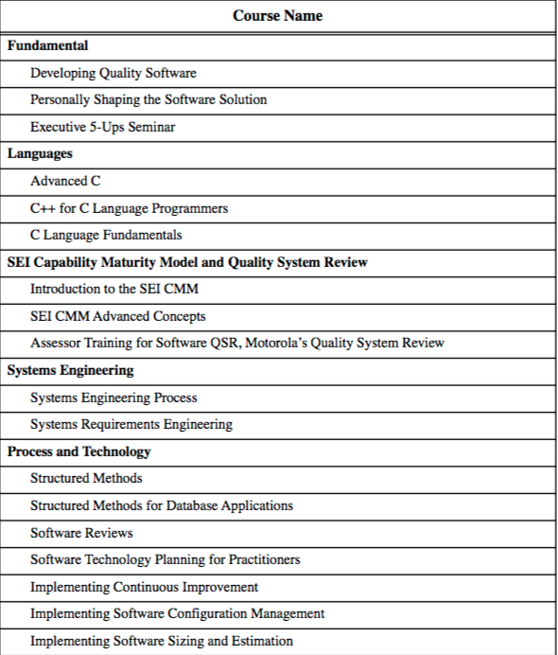

For training purposes, AtHoc will implement a train the trainer program, while using a small agile team. The CIO will train the trainer, who will be the Team lead, sometimes called “Scrum Master. The scrum master is responsible for all other team members, who are the programmers that model, program, test, release, among other responsibilities. The team leader will also train the product owner. This product owner prioritizes work item lists.
As a company, we want to measure our metrics because errors and vulnerabilities always exist. We measure them to know if our application is more secure today than it was yesterday, or less secure. It also lets us know if our training really made a difference. Last but not least, it will help to let us know when our system is secure.
Our company uses two practical methods for measure metrics. They are Quantify the Secure Development Lifecycle, and Use Source Code Analysis to Measure Security.
- Quantify the Secure Development Lifecycle
  - Evaluate the current state of software security and design a plan for maintaining it throughout the cycle.
  - Specify the threats.
  - Review the code for vulnerabilities introduced during the development.
  - Test the code for vulnerabilities based on threats and risk assessment.
  - Build a gate to prevent applications with vulnerabilities from going into production.
  - Measure the success of the security plan so that the process can be improved.
  - Educate stakeholders about security (Chess, 2012).
Use Source Code Analysis to Measure Security
All companies, organizations, have source code in common. Many vulnerabilities can manifest themselves into the source code. The source code is the key artifact to measure as part of assessing software security. A source code analyzer will search the code for vulnerability patterns that can represent potential threats. The analyzer should identify vulnerabilities of concern. Developers will use the analyzer on a normal basis as part of their development work. A software team will also use the analyzer for periodic code review (Chess, 2012).
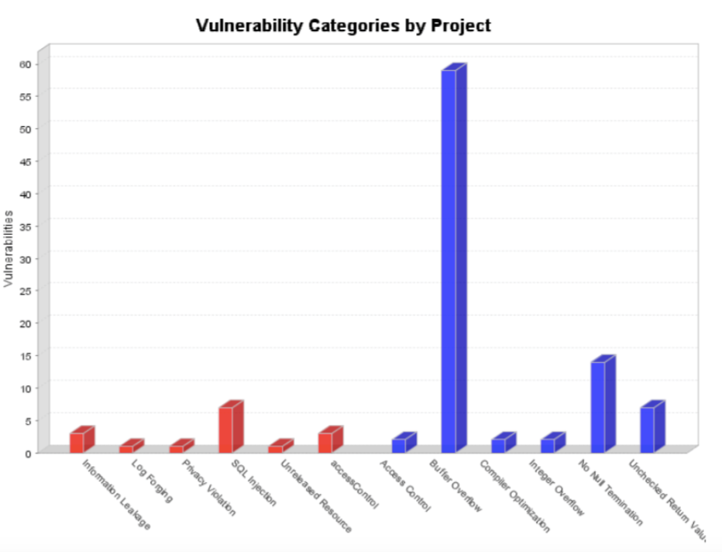
AtHoc Small Agile Software Development Team
CIO – IT director responsible for delegating projects, adhering to company and IT infrastructure policy, training, and implementing and evaluating guidelines.
Team Lead – Also know as “Scrum Master”. Team coach, project manager. Responsible for facilitating the team, obtaining resources and protecting it from problems.
Team Members – Programmers, developers. Responsible for the creation and delivery of a system. This includes modeling, programming, testing, and release of activities.
Product Owner – represents the stakeholders. Responsible for prioritizing work item lists, making decisions, and providing information (Ambler, 2012).

References
SDLC - Overview. (n.d.). Retrieved from http://www.tutorialspoint.com/sdlc/sdlc_overview.htm
Jarzombek, J. (2012). Software Assurance: Enabling Security and Resilience throughout the Software Lifecycle. Retrieved from http://csrc.nist.gov/groups/SMA/forum/documents/october-2012_fcsm-jjarzombek.pdf
AtHoc (2017). AtHoc and the Department of Defense. Retrieved from https://defense-military.athoc.com/industries/defense-military/
Awad, M. (2005). A Comparison between Agile and Traditional Software Development Methodologies. Retrieved from http://www.unf.edu/~broggio/cen6940/ComparisonAgileTraditional.pdf
Wells, D. (2013) Extreme Programming. Retrieved From http://www.extremeprogramming.org/
Nguyen, T. (2015). Development Methods. Retrieved from http://www.umsl.edu/~thnbp3/insf6840/
Ambler, S. (2012). Roles on Agile Teams: From Small to Large Teams. Retrieved from http://www.ambysoft.com/essays/agileRoles.html
ATG Security Guide. (n.d.). Retrieved from https://docs.oracle.com/cd/E35319_01/Platform.10-2/ATGCommerceSecurityGuide/ATGCommerceSecurityGuide.pdf

Awad, M. A. (2005). A Comparison between Agile and Traditional Software Development Methodologies. Retrieved from http://www.unf.edu/~broggio/cen6940/ComparisonAgileTraditional.pdf
BugBlast Next-gen AppSec Platform. (n.d.). Retrieved from https://buguroo.com/products/bugblast-next-gen-appsec-platform
Carpenter, M. (1995, September). Training Guidelines: Creating a Training Plan for a Software Organization. Retrieved from http://www.sei.cmu.edu/reports/95tr007.pdf
Chapter 13. File System Connector. (n.d.). Retrieved from http://docs.jboss.org/jbossdna/0.7/manuals/reference/html/file-system-connector.html
Chess, B. (2012). Metrics That Matter: Quantifying Software Security Risk. Retrieved from https://samate.nist.gov/SSATTM_Content/papers/Metrics That Matter - Chess.pdf
Consulting. (n.d.). Retrieved from http://www.dataskill.com/services/consulting/
Faster delivery of secure, reliable, and conformant code | Klocwork. (n.d.). Retrieved from http://www.klocwork.com/products-services/klocwork/static-code-analysis
Jarzombek, J. (2012). Software Assurance: Enabling Security and Resilience throughout the Software Lifecycle. Retrieved from http://csrc.nist.gov/groups/SMA/forum/documents/october-2012_fcsm-jjarzombek.pdf
Nguyen, T. (2015). Development Methods. Retrieved from http://www.umsl.edu/~thnbp3/insf6840
Product Management | UserVoice. (n.d.). Retrieved from https://www.uservoice.com/product/product-management/
Reviewing Code for Cross-site scripting. (n.d.). Retrieved from https://www.owasp.org/index.php/Reviewing_code_for_Cross-site_scripting_vulnerabilities
SDLC - Overview. (n.d.). Retrieved from http://www.tutorialspoint.com/sdlc/sdlc_overview.htm
The Most Powerful Application Security Platform on the Planet. (n.d.). Retrieved from http://www.veracode.com/

